***Dt : 13/9/2022***

***Diagram:***

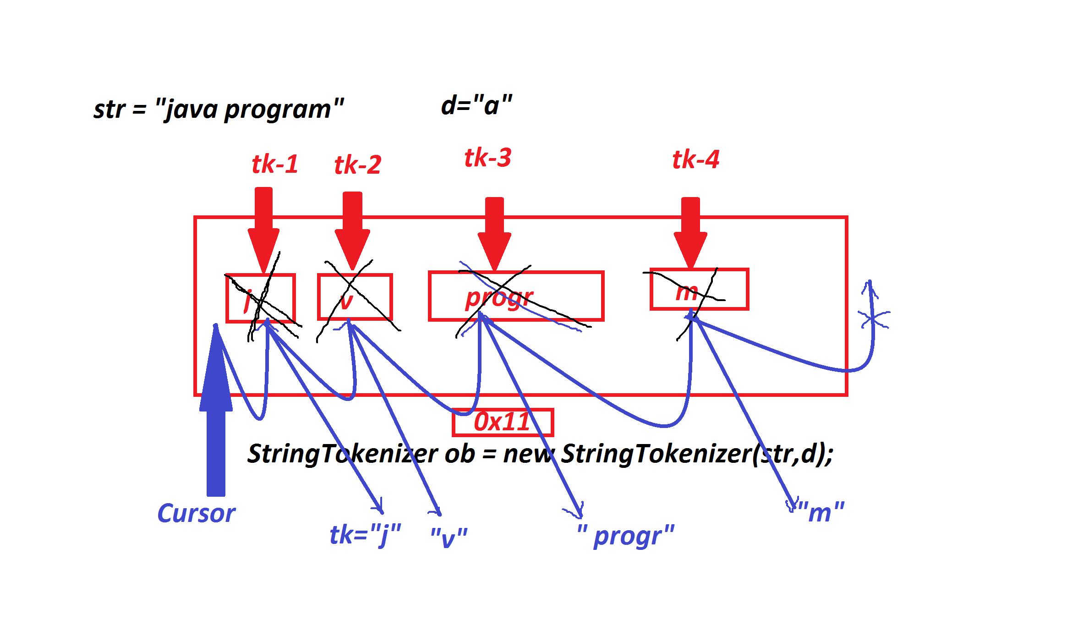

***=======================================================***

***\*imp***

***(b)StringJoiner class:***

***=>'StringJoiner' class is from java.util package introduced by***

***Java8(2014) version and which is used to join the strings based on***

***delimiter.***

***=>The following are some important methods of StringJoiner:***

***public java.util.StringJoiner setEmptyValue***

***(java.lang.CharSequence);***

***public java.lang.String toString();***

***public java.util.StringJoiner add(java.lang.CharSequence);***

***public java.util.StringJoiner merge(java.util.StringJoiner);***

***public int length();***

***Ex : DemoJoiner.java***

***package maccess;***

***import java.util.*;***

***public class DemoJoiner {***

***public static void main(String[] args) {***

***Scanner s = new Scanner(System.in);***

***System.out.println("====Emp Date of Joining====");***

***StringJoiner sj1 = new StringJoiner("/");***

***sj1.setEmptyValue("No record available...");***

***System.out.println(sj1.toString());***

***System.out.println("Enter the Date:");***

***sj1.add(s.nextLine());***

***System.out.println("Enter the month(Only numeric):");***

***sj1.add(s.nextLine());***

***System.out.println("Enter the Year:");***

***sj1.add(s.nextLine());***

***System.out.println("DOJ : "+sj1.toString());***

***System.out.println("====Emp Address====");***

***StringJoiner sj2 = new StringJoiner("-");***

***sj2.setEmptyValue("No Address Available...");***

***System.out.println(sj2.toString());***

***System.out.println("Enter the City:");***

***sj2.add(s.nextLine());***

***System.out.println("Enter the PhoneNo:");***

***sj2.add(s.nextLine());***

***System.out.println("Enter the MailId:");***

***sj2.add(s.nextLine());***

***System.out.println("Contact Details : "+sj2.toString());***

***System.out.println("====merge operation====");***

***sj1.merge(sj2);***

***System.out.println(sj1.toString());***

***System.out.println("length : "+sj1.length());***

***s.close();***

***}***

***}***

***o/p:***

***====Emp Date of Joining====***

***No record available...***

***Enter the Date:***

***12***

***Enter the month(Only numeric):***

***09***

***Enter the Year:***

***1999***

***DOJ : 12/09/1999***

***====Emp Address====***

***No Address Available...***

***Enter the City:***

***Hyd***

***Enter the PhoneNo:***

***9898981234***

***Enter the MailId:***

***r@gmail.com***

***Contact Details : Hyd-9898981234-r@gmail.com***

***====merge operation====***

***12/09/1999/Hyd-9898981234-r@gmail.com***

***length : 37***

***=========================================================***

***faq:***

***define Utility classes?***

***=>The classes which perform operations on other objects are known***

***as Utility classes.***

***========================================================***

***Assignment:***

***Update StudentDetails with result program by validating rollNo***

***with branch.***

***01 - Civil***

***02 - EEE***

***03 - Mech***

***04 - Ece***

***05 - CSE***

***step-1 : read rollNo and find the branch based on branchCode***

***step-2 : read name***

***step-3 : read branch and check the branch(Civil....)***

***step-4 : verify the rollNo belongs to entered branch or not***

***=>Then read 6 sub-marks***

***=============================================================***

***\*imp***

***WrapperClasses in Java:***

***=>The pre-defined classes from java.lang package which are used***

***to make primitive datatypes available in the form of objects are***

***known as WrapperClasses.***

***=>Every Primitive DataType will have its own WrapperClass and***

***there are 8 WrapperClasses.***

***=>The following is the list of WrapperClasses:***

***DataType WrapperClass***

***byte Byte***

***short Short***

***int Integer***

***long Long***

***float Float***

***double Double***

***char Character***

***boolean Boolean***

***--------------------------------------------------------------***